MSSV: 22002575

Họ tên SV: Trần Gia Nguyên Phong

Notes: Filename: Lab04_HoTen_MSSV_Library.docx

**Homework**

**Library Database**

1. **Create Database Library**

SQL Statement

CREATE DATABASE Library ON PRIMARY

(

NAME = 'Library',

FILENAME = 'D:\Desktop\WorkSpace\SQL\InSchool\Week 3\Library.mdf',

SIZE = 3072KB,

MAXSIZE = UNLIMITED,

FILEGROWTH = 1024KB

)

LOG ON

(

NAME = 'Library_log',

FILENAME = 'D:\Desktop\WorkSpace\SQL\InSchool\Week 3\Library_log.ldf',

SIZE = 1024KB,

MAXSIZE = 2048KB,

FILEGROWTH = 10%

);

--GO

GO

USE Library;

GO

1. **Create tables – Priamry Key – Foreign Key**

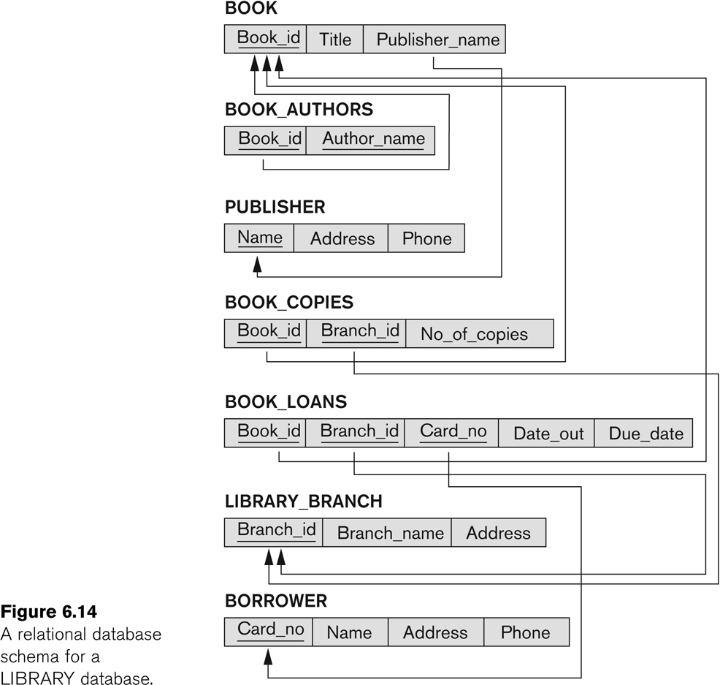

**Table Structure:**

* Publisher

|  |  |  |
| --- | --- | --- |
| **Field Name** | **Data Type** | **Null** |
| **Name** | VARCHAR(20) | NOT NULL |
| Address | VARCHAR(30) |  |
| Phone | VARCHAR(10) |  |

* Book

|  |  |  |
| --- | --- | --- |
| **Field Name** | **Data Type** | **Null** |
| **Book_ID** | SMALLINT | NOT NULL |
| Ttile | VARCHAR(30) | NOT NULL |
| Publisher_Name | VARCHAR(20) |  |

* Library_Branch

|  |  |  |
| --- | --- | --- |
| **Field Name** | **Data Type** | **Null** |
| **Branch_ID** | SMALLINT | NOT NULL |
| Branch_Name | VARCHAR(20) | NOT NULL |
| Address | VARCHAR(30) |  |

* Book_Authors

|  |  |  |
| --- | --- | --- |
| **Field Name** | **Data Type** | **Null – PK** |
| **Book_ID** | SMALLINT | NOT NULL |
| **Author_Name** | VARCHAR(20) | NOT NULL |

* Borrower

|  |  |  |
| --- | --- | --- |
| **Field Name** | **Data Type** | **Null – PK** |
| **Card_NO** | SMALLINT | NOT NULL |
| Name | VARCHAR(20) |  |
| Adress | VARCHAR(30) |  |
| Phone | VARCHAR(10) |  |

* Book_Copies

|  |  |  |
| --- | --- | --- |
| **Field Name** | **Data Type** | **Null – PK** |
| **Book_ID** | SMALLINT | NOT NULL |
| **Branch_ID** | SMALLINT | NOT NULL |
| No_Of_Copies | SMALLINT |  |

* Book_Loans

|  |  |  |
| --- | --- | --- |
| **Field Name** | **Data Type** | **Null – PK** |
| **Book_ID** | SMALLINT | NOT NULL |
| **Branch_ID** | SMALLINT | NOT NULL |
| **Card_NO** | SMALLINT | NOT NULL |
| Date_Out | DATETIME |  |
| Due_Date | DATETIME |  |

SQL Statement

--=================================

--create table data

--Publisher data

CREATE TABLE Publisher (

Name VARCHAR(20) NOT NULL,

Address VARCHAR(30) NULL,

Phone VARCHAR(10) NULL

);

GO

--Book data

CREATE TABLE Book (

Book_ID SMALLINT NOT NULL,

Title VARCHAR(30) NOT NULL,

Publisher_Name VARCHAR(20) NULL

);

GO

--Library Branch data

CREATE TABLE Library_Branch (

Branch_ID SMALLINT NOT NULL,

Branch_Name VARCHAR(20) NOT NULL,

Address VARCHAR(30) NOT NULL

);

GO

--Book Authors data

CREATE TABLE Book_Authors (

Book_ID SMALLINT NOT NULL,

Author_Name VARCHAR(20) NOT NULL

);

GO

--Borrower data

CREATE TABLE Borrower (

Card_NO SMALLINT NOT NULL,

Name VARCHAR(20) NULL,

Address VARCHAR(30) NULL,

Phone VARCHAR(10) NULL

);

GO

--Book Copies data

CREATE TABLE Book_Copies (

Book_ID SMALLINT NOT NULL,

Branch_ID SMALLINT NOT NULL,

No_Of_Copies SMALLINT NULL

);

GO

--Book Loans data

CREATE TABLE Book_Loans (

Book_ID SMALLINT NOT NULL,

Branch_ID SMALLINT NOT NULL,

Card_NO SMALLINT NOT NULL,

Date_Out DATETIME NULL,

Due_Date DATETIME NULL

);

GO

--=================================

--Create primary key for table data

ALTER TABLE Publisher

ADD Constraint pk_publisher PRIMARY KEY (Name);

GO

ALTER TABLE Book

ADD Constraint pk_bk PRIMARY KEY (Book_ID);

GO

ALTER TABLE Library_Branch

ADD Constraint pk_lib_br PRIMARY KEY (Branch_ID);

GO

ALTER TABLE Book_Authors

ADD Constraint pk_bk_au PRIMARY KEY (Book_ID, Author_Name);

GO

ALTER TABLE Borrower

ADD Constraint pk_bor PRIMARY KEY (Card_NO);

GO

ALTER TABLE Book_Copies

ADD Constraint pk_bk_cop PRIMARY KEY (Book_ID, Branch_ID);

GO

ALTER TABLE Book_Loans

ADD Constraint pk_bk_loans PRIMARY KEY (Book_ID, Branch_ID, Card_NO);

GO

--=====================================

--Create foreign key for table data

ALTER TABLE Book

ADD CONSTRAINT fk_bk_publisher_name FOREIGN KEY (Publisher_Name) REFERENCES Publisher(Name);

GO

ALTER TABLE Book_Authors

ADD CONSTRAINT fk_bk_author_bk_id FOREIGN KEY (Book_ID) REFERENCES Book(Book_ID);

GO

ALTER TABLE Book_Copies

ADD CONSTRAINT fk_bk_copies_bk_id FOREIGN KEY (Book_ID) REFERENCES BOOK(Book_ID);

GO

ALTER TABLE Book_Copies

ADD CONSTRAINT fk_bk_copies_branch_id FOREIGN KEY (Branch_ID) REFERENCES Library_Branch(Branch_ID);

GO

ALTER TABLE Book_Loans

ADD CONSTRAINT fk_bk_loans_bk_id FOREIGN KEY (Book_ID) REFERENCES BOOK(Book_ID);

GO

ALTER TABLE Book_Loans

ADD CONSTRAINT fk_bk_loans_branch_id FOREIGN KEY (Book_ID) REFERENCES BOOK(Book_ID);

GO

ALTER TABLE Book_Loans

ADD CONSTRAINT fk_bk_loans_card_no FOREIGN KEY (Card_NO) REFERENCES Borrower(Card_NO);

GO

1. **Insert Data**

* Publisher

|  |  |  |
| --- | --- | --- |
| Name | Address | Phone |
| Amazing Books | 9012 Great Rd | 333-3333 |
| Plume | 1234 Cool Ave | 555-5555 |
| Random House | 5678 Neat St | 444-4444 |

* Book

|  |  |  |
| --- | --- | --- |
| Book_ID | Title | Publisher_Name |
| 1 | The Lost Tribe | Random House |
| 2 | Farook | Random House |
| 3 | Carrie | Plume |
| 4 | The Dark Tower VII | Plume |
| 5 | Red Dawn | Amazing Books |
| 6 | Zepplin | Amazing Books |

* Library_Branch

|  |  |  |
| --- | --- | --- |
| Branch_ID | Branch_Name | Address |
| 1 | Sharpstown | 4321 Wonder Road |
| 2 | Central | 9876 Flower St |

* Book_Authors

|  |  |
| --- | --- |
| Book_ID | Author_Name |
| 1 | Master Nook |
| 2 | Jardumba Nartangula |
| 3 | Stephen King |
| 4 | Stephen King |
| 5 | John Smith |
| 6 | Yasunori Mitsugi |

* Borrower

|  |  |  |  |
| --- | --- | --- | --- |
| Card_No | Name | Address | Phone |
| 1 | John Doe | 1234 Plain St | 532-2432 |
| 2 | Jane Doe | 1234 Plain St | 532-2432 |
| 3 | Mike Jackson | 1111 nowhere | 222-2222 |

* Book_Copies

|  |  |  |
| --- | --- | --- |
| Book_ID | Branch_ID | No_Of_Copies |
| 1 | 1 | 10 |
| 1 | 2 | 10 |
| 2 | 1 | 10 |
| 2 | 2 | 10 |
| 3 | 1 | 10 |
| 3 | 2 | 10 |
| 4 | 1 | 10 |
| 4 | 2 | 10 |
| 5 | 1 | 10 |
| 5 | 2 | 10 |
| 6 | 2 | 10 |

* Book_Loans

|  |  |  |  |  |
| --- | --- | --- | --- | --- |
| Book_ID | Branch_ID | Card_No | Date_Out | Due_Date |
| 1 | 1 | 1 | 12/15/2005 | NULL |
| 1 | 2 | 1 | 11/24/2005 | NULL |
| 2 | 1 | 2 | 12/15/2005 | NULL |
| 2 | 2 | 2 | 11/24/2005 | NULL |
| 3 | 1 | 3 | 12/15/2005 | NULL |
| 3 | 2 | 3 | 11/24/2005 | NULL |
| 4 | 1 | 1 | 12/15/2005 | NULL |
| 4 | 2 | 1 | 11/24/2005 | NULL |
| 5 | 1 | 2 | 12/15/2005 | NULL |
| 5 | 2 | 2 | 11/24/2005 | NULL |
| 6 | 1 | 3 | 12/15/2005 | NULL |
| 6 | 2 | 3 | 11/19/2009 | NULL |

SQL Statement

--Insert table data

--Publisher

INSERT INTO Publisher

VALUES ('Amazing Books', '9012 Great Rd', '333-3333');

GO

INSERT INTO Publisher

VALUES ('Plume', '1234 Cool Ave', '555-5555');

GO

INSERT INTO Publisher

VALUES ('Random House', '5678 Neat St', '444-4444');

GO

--Book

INSERT INTO Book

VALUES (1, 'The Lost Tribe', 'Random House');

GO

INSERT INTO Book

VALUES (2, 'Farook', 'Random House');

GO

INSERT INTO Book

VALUES (3, 'Carrie', 'Plume');

GO

INSERT INTO Book

VALUES (4, 'The Dark Tower VII', 'Plume');

GO

INSERT INTO Book

VALUES (5, 'Red Dawn', 'Amazing Books');

GO

INSERT INTO Book

VALUES (6, 'Zepplin', 'Amazing Books');

GO

--Insert Library Branch

INSERT INTO Library_Branch

VALUES (1, 'Sharpstown', '4321 Wonder Road');

GO

INSERT INTO Library_Branch

VALUES (2, 'Central', '9876 Flower St');

GO

--Insert Book Authors

INSERT INTO Book_Authors

VALUES (1, 'Master Nook');

GO

INSERT INTO Book_Authors

VALUES (2, 'Jardumba Nartangula');

GO

INSERT INTO Book_Authors

VALUES (3, 'Stephen King');

GO

INSERT INTO Book_Authors

VALUES (4, 'Stephen King');

GO

INSERT INTO Book_Authors

VALUES (5, 'John Smith');

GO

INSERT INTO Book_Authors

VALUES (6, 'Yasunori Mitsugi');

GO

--Borrower

INSERT INTO Borrower

VALUES (1, 'John Doe', '1234 Plain St', '532-2432');

GO

INSERT INTO Borrower

VALUES (2, 'Jane Doe', '1234 Plain St', '532-2432');

GO

INSERT INTO Borrower

VALUES (3, 'Mike Jackson', '1111 nowhere', '222-2222');

GO

--Book Copies

INSERT INTO Book_Copies

VALUES (1, 1, 10);

GO

INSERT INTO Book_Copies

VALUES (1, 2, 10);

GO

INSERT INTO Book_Copies

VALUES (2, 1, 10);

GO

INSERT INTO Book_Copies

VALUES (2, 2, 10);

GO

INSERT INTO Book_Copies

VALUES (3, 1, 10);

GO

INSERT INTO Book_Copies

VALUES (3, 2, 10);

GO

INSERT INTO Book_Copies

VALUES (4, 1, 10);

GO

INSERT INTO Book_Copies

VALUES (4, 2, 10);

GO

INSERT INTO Book_Copies

VALUES (5, 1, 10);

GO

INSERT INTO Book_Copies

VALUES (5, 2, 10);

GO

INSERT INTO Book_Copies

VALUES (6, 2, 10);

GO

--Book Loans

INSERT INTO Book_Loans

VALUES (1, 1, 1, '12/15/2005', NULL);

GO

INSERT INTO Book_Loans

VALUES (1, 2, 1, '11/24/2005', NULL);

GO

INSERT INTO Book_Loans

VALUES (2, 1, 2, '12/15/2005', NULL);

GO

INSERT INTO Book_Loans

VALUES (2, 2, 2, '11/24/2005 ', NULL);

GO

INSERT INTO Book_Loans

VALUES (3, 1, 3, '12/15/2005 ', NULL);

GO

INSERT INTO Book_Loans

VALUES (3, 2, 3, '11/24/2005 ', NULL);

GO

INSERT INTO Book_Loans

VALUES (4, 1, 1, '12/15/2005 ', NULL);

GO

INSERT INTO Book_Loans

VALUES (4, 2, 1, '11/24/2005 ', NULL);

GO

INSERT INTO Book_Loans

VALUES (5, 1, 2, '12/15/2005 ', NULL);

GO

INSERT INTO Book_Loans

VALUES (5, 2, 2, '11/24/2005 ', NULL);

GO

INSERT INTO Book_Loans

VALUES (6, 1, 3, '12/15/2005 ', NULL);

GO

INSERT INTO Book_Loans

VALUES (6, 2, 3, '11/19/2009 ', NULL);

GO

1. **Queries** (include result queries)
   1. How many copies of the book titled The Lost Tribe are owned by the library branch whose name is "Sharpstown"?

**Query**:

SELECT Bk.Book_ID, Bk.Title, Lib_Branch.Branch_Name,Bk_Cp.No_Of_Copies

FROM Book_Copies AS Bk_Cp, Book AS Bk, Library_Branch AS Lib_Branch

WHERE Bk.Title = 'The Lost Tribe' AND Lib_Branch.Branch_Name = 'Sharpstown' AND Bk_Cp.Book_ID = 1 AND Bk_Cp.Branch_ID = 1;

GO

**Result**:



* 1. How many copies of the book titled The Lost Tribe are owned by each library branch?

**Query**:

SELECT Bk_Cp.Book_ID, Bk.Title, Lib_Br.Branch_ID, Lib_Br.Branch_Name, Bk_Cp.No_Of_Copies

FROM Book_Copies AS Bk_Cp, Book AS Bk, Library_Branch AS Lib_Br

WHERE (Bk_Cp.Book_ID = 1 AND Bk_Cp.Book_ID = Bk.Book_ID) AND Bk_Cp.Branch_ID = Lib_Br.Branch_ID;

GO

**Result**:

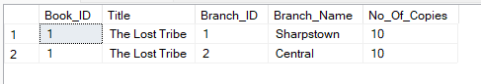

* 1. Retrieve the names of all borrowers who do not have any books checked out.

**Query**:

SELECT Name

FROM Borrower

WHERE Card_NO NOT IN ( SELECT Card_NO from Book_Loans);

GO

**Result**:

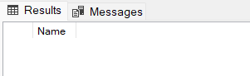

* 1. For each book that is loaned out from the "Sharpstown" branch and whose DueDate is today, retrieve the book title, the borrower's name, and the borrower's address.

**Query**:

SELECT Bk.Title, B.Name, B.Address

FROM Library_Branch AS Lib_Br, Borrower AS B, Book_Loans AS Bk_L, Book AS Bk

WHERE Lib_Br.Branch_Name = 'Sharpstown' AND Lib_Br.Branch_ID = Bk_L.Branch_ID

AND Bk_L.Due_Date = '10/5/2022' AND B.Card_NO = Bk_L.Card_NO AND Bk.Book_ID = Bk.Book_ID;

GO

**Result**:

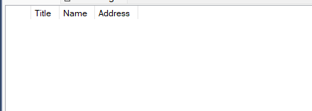

* 1. For each library branch, retrieve the branch name and the total number of books loaned out from that branch.

**Query**:

SELECT * FROM Library_Branch;

GO

SELECT * FROM Book_Loans;

GO

SELECT Lib_Br.Branch_Name, COUNT(Lib_Br.Branch_ID) AS Count_Lib_Br

FROM Library_Branch AS Lib_Br, Book_Loans AS Bk_L

WHERE Lib_Br.Branch_ID = Bk_L.Branch_ID

GROUP BY Lib_Br.Branch_Name;

GO

**Result**:

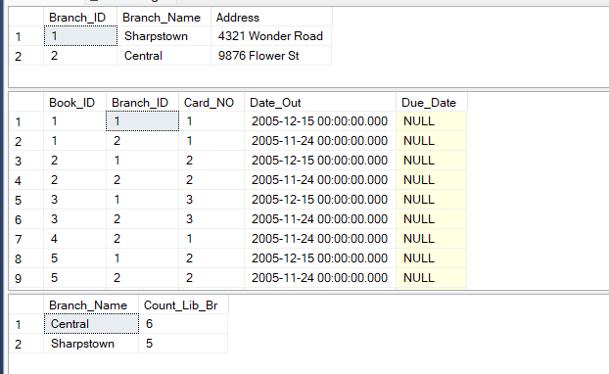

* 1. Retrieve the names, addresses, and number of books checked out for all borrowers who have more than five books checked out.

**Query**:

SELECT * FROM Borrower;

GO

SELECT * FROM Book_Loans;

GO

SELECT B.Name, B.Address, COUNT(*) AS Number_Of_Book

FROM Borrower AS B, Book_Loans AS Bk_L

WHERE B.Card_NO = Bk_L.Card_NO

GROUP BY B.Name, B.Address

HAVING COUNT(*) > 5;

GO

**Result**:

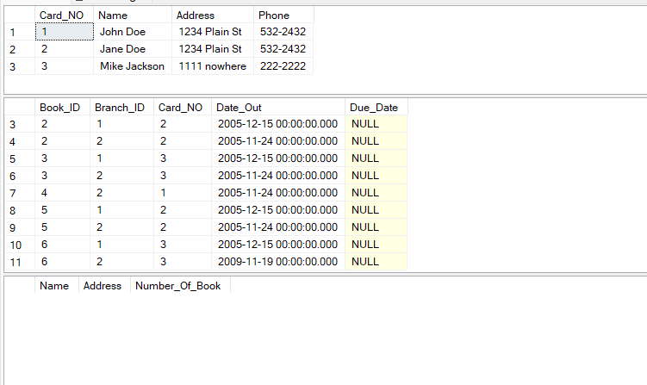

* 1. For each book authored (or co-authored) by "Stephen King", retrieve the title and the number of copies owned by the library branch whose name is "Central".

**Query**:

SELECT * FROM Book_Authors;

GO

SELECT * FROM Library_Branch

GO

SELECT * FROM Book_Copies;

GO

SELECT Book_Copies.Book_ID, Book_Authors.Author_Name, Library_Branch.Branch_Name, Book_Copies.No_Of_Copies

FROM

(Book_Copies INNER JOIN Book_Authors ON Book_Copies.Book_ID = Book_Authors.Book_ID)

INNER JOIN Library_Branch ON Book_Copies.Branch_ID = Library_Branch.Branch_ID

WHERE

(Book_Copies.Book_ID = Book_Authors.Book_ID AND Book_Copies.Branch_ID = Library_Branch.Branch_ID)

AND Library_Branch.Branch_Name = 'Central' AND (Book_Copies.Book_ID = 3 OR Book_Copies.Book_ID = 4);

GO

**Result**:

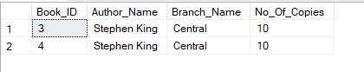

**END**